AFTER NOT NULL FILTERING:

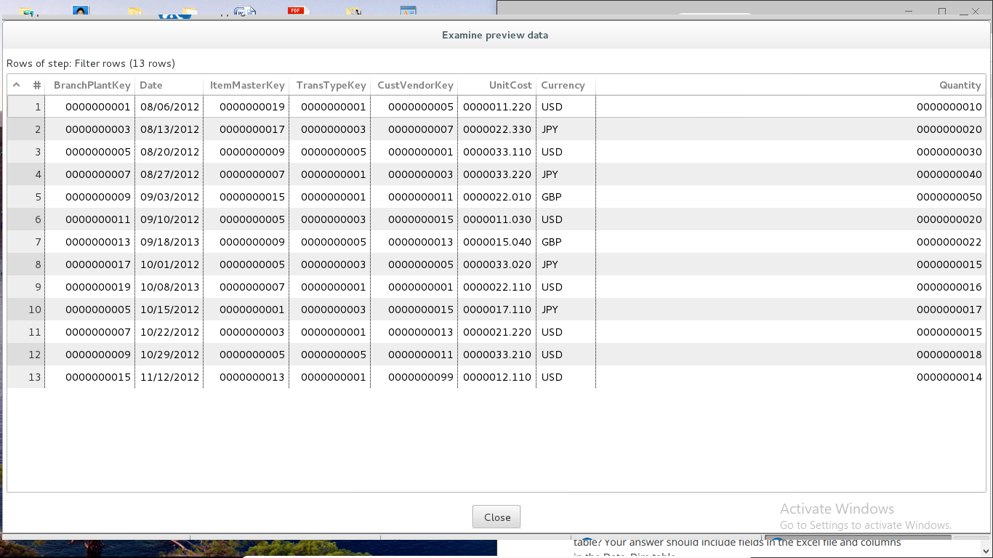

rows appear in the preview result (or the Written column in the step metrics) after merging the Excel file with the Date_Dim table:

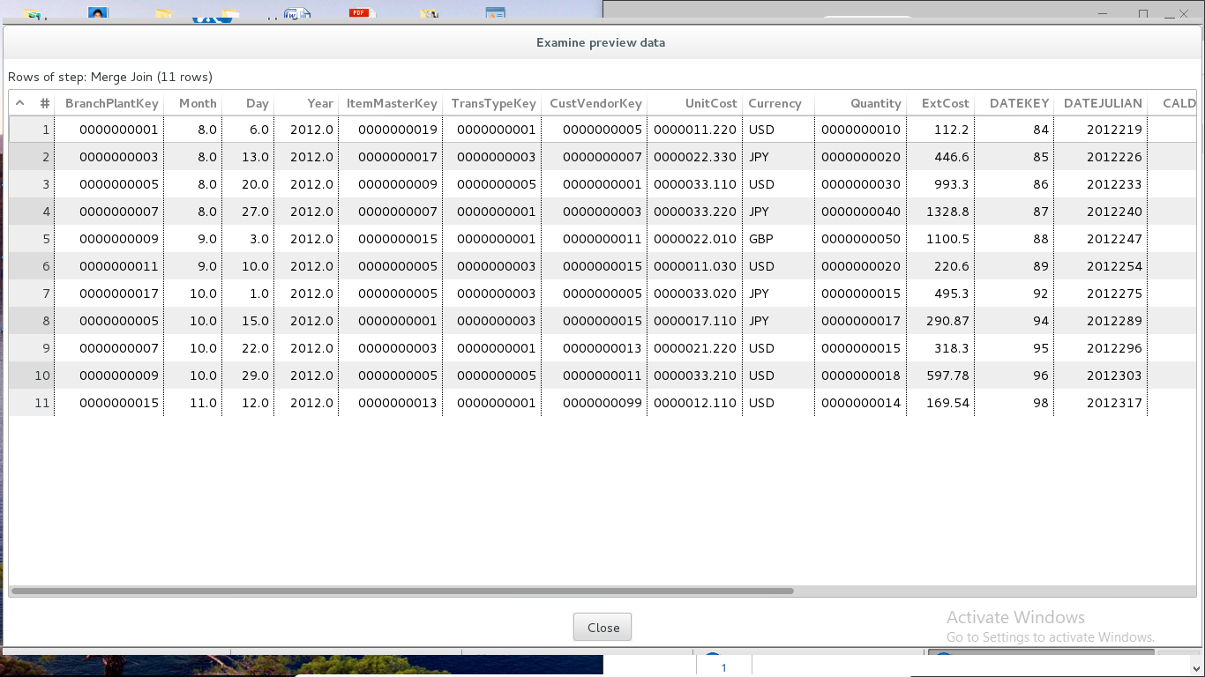

rows appear in the preview result (or the Written column in the step metrics) after merging with the Trans_Type_Dim table:

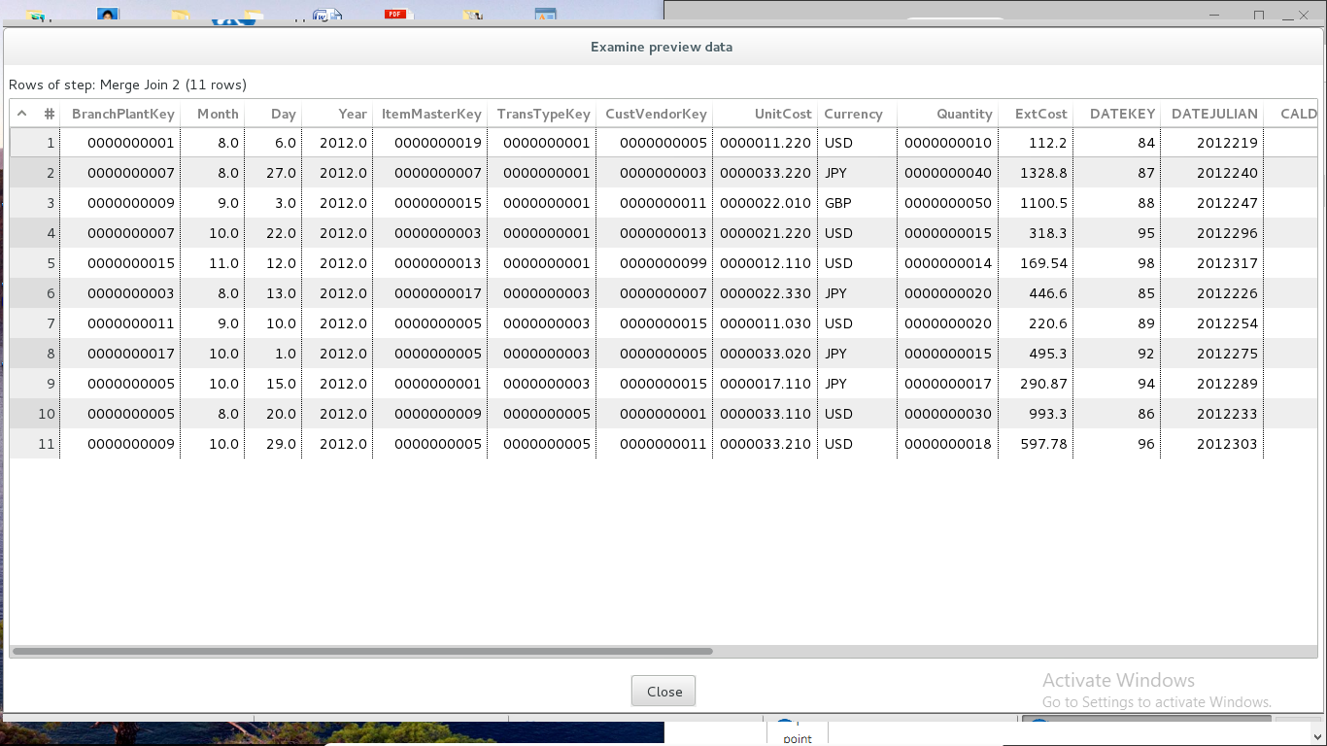

rows appear in the preview result (or the Written column in the step metrics) after merging with the Cust_Vendor_Dim table:

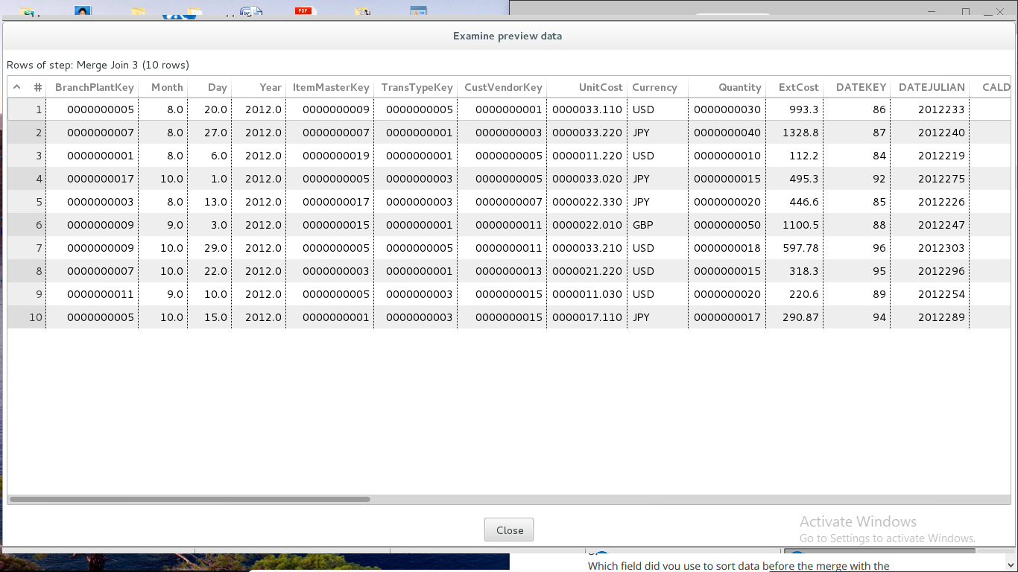

rows appear in the preview result (or the Written column in the step metrics) after merging with the Item_Master_Dim table:

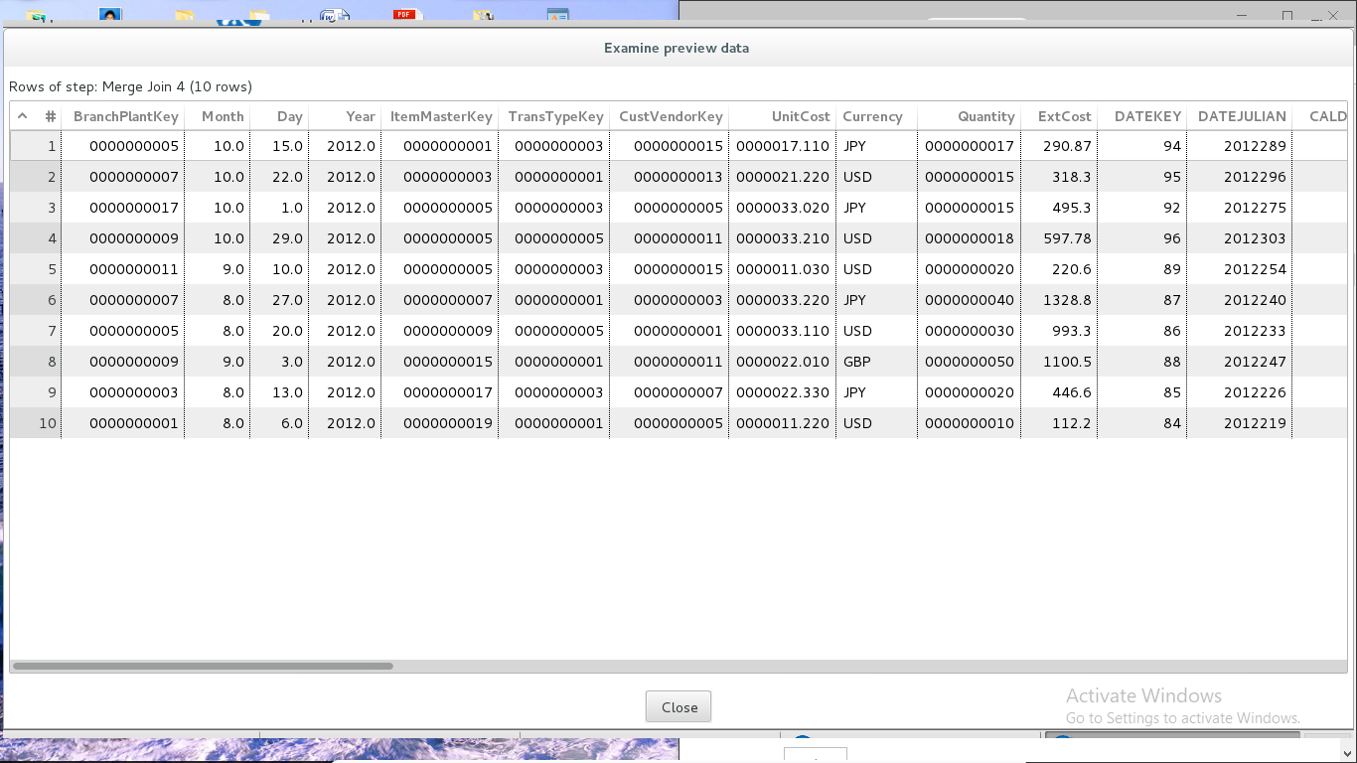

rows appear in the preview result (or the Written column in the step metrics) after merging with the Branch_Plant_Dim table:

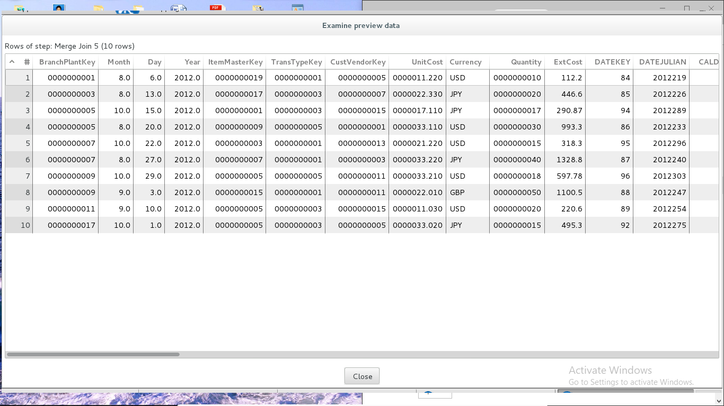

rows appear in the preview result (or the Written column in the step metrics) after merging with the INVENTORY_FACT table:

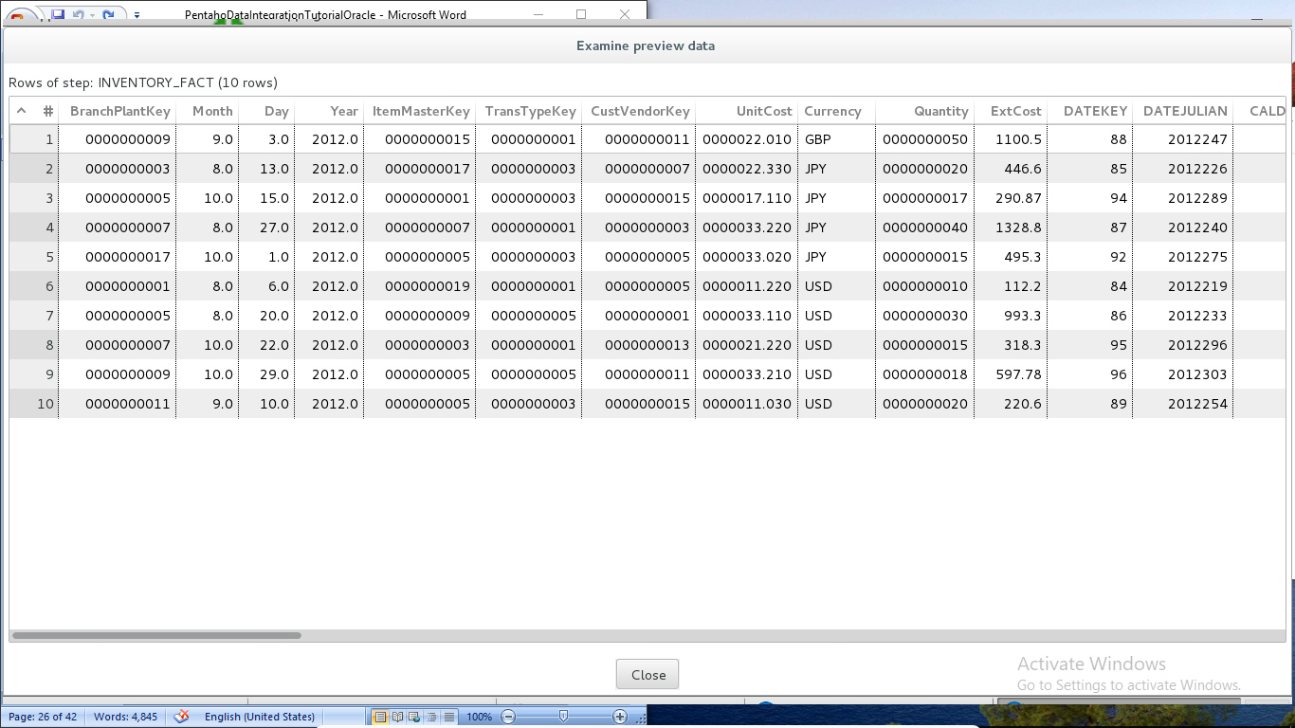

FINAL TRANSFORMATION:

